#include<stdio.h>
#include<stdlib.h>
#define N 1000
struct node
{
int key;
struct node* next;
};
typedef struct node Node;
Node* getnode()
{
return (Node*)malloc(sizeof(Node));
}
void display(Node* list)
{
Node *temp;
for(temp=list;temp!=NULL;temp=temp->next)
printf("%d ",temp->key);
printf("\n");
}
int search(Node* list, int val)
{
Node *temp;
int f=0;
for(temp=list;temp!=NULL;temp=temp->next)
{
if(temp->key==val)
{
f=1;
break;
}
}
return f;
}
int main()
{
Node *head, *temp, *prev;
int n,val;
head=NULL;
scanf("%d",&n);
while(n!=-1)
{
if(head==NULL)
{
head=getnode();
head->key=n;
head->next=NULL;
prev=head;
}
else
{
temp=getnode();
temp->key=n;
temp->next=NULL;
prev->next=temp;
prev=temp;
}
scanf("%d",&n);
}
scanf("%d",&val);
display(head);
int q=search(head,val);

printf("%d\n",q);
}

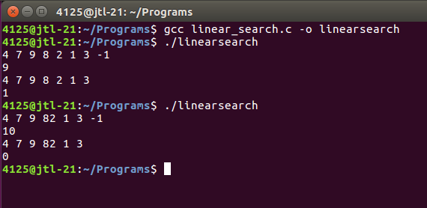

#include<stdio.h>
#define N 1000
void sort(int a[], int n){
for(int i=0;i<n;i++){
for(int j=i+1;j<n;j++){
if(a[j]<a[i]){
int t=a[i];
a[i]=a[j];
a[j]=t;
}
}
}
}
int binary_search(int a[], int n, int val){
int b=0,e=n-1,m;
sort(a,n);
while(b<=e){
m=(b+e)/2;
if(a[m]==val)
return m;
else if(a[m]<val)
b=m+1;
else
e=m-1;
}
return -1;
}
int main(){
int a[N],n,q;
scanf("%d",&n);
for(int i=0;i<n;i++){
scanf("%d",&a[i]);
}
scanf("%d",&q);
int s=binary_search(a,n,q);
printf("%d\n",s);
}

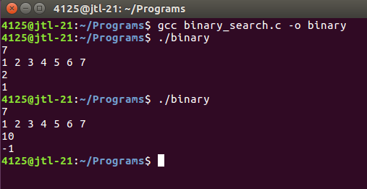

#include<stdio.h>
#include<stdlib.h>
struct node
{
int key;
struct node *next;
};
typedef struct node Node;
Node * getnode(Node * n, int val)
{
n=(Node *)malloc(sizeof(Node));
n->key=val;
n->next=NULL;
return n;
}
Node * insert(Node * head, int ref, int val)
{
if(ref<0)
{
Node *t;
t=getnode(t,val);
t->next=head;
head=t;
}
else
{
Node *t,*p;
for(t=head;t->key!=ref && t->next!=NULL;t=t->next);
p=getnode(p,val);
p->next=t->next;
t->next=p;
}
return head;
}
Node * delete(Node * head, int ref)
{
Node *p,*t;
if(head->key==ref)
{
p=head;
head=head->next;
free(p);
}
else
{
for(t=head;t->next->key!=ref && t->next->next!=NULL;t=t->next);
p=t->next;
t->next=p->next;
free(p);
}
return head;

}
void display(Node * head)
{
Node * t;
for(t=head;t!=NULL;t=t->next)
{
printf("%d ",t->key);
}
printf("\n");
}

void main()
{
Node *head,*temp,*prev;
int n,ri,val,rd;
head=NULL;
scanf("%d",&n);
while(n!=-1)
{
if(head==NULL)
{
head=getnode(head,n);
prev=head;
}
else
{
temp=getnode(temp,n);
prev->next=temp;
prev=temp;
}
scanf("%d",&n);
}
display(head);
scanf("%d %d",&ri,&val);
head=insert(head,ri,val);
display(head);
scanf("%d",&rd);
head=delete(head,rd);
display(head);
}

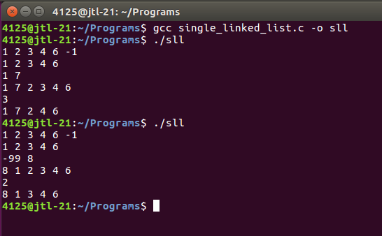

#include<stdio.h>
#include<stdlib.h>
struct node
{
int data;
struct node *next;
};
typedef struct node Node;
Node * getnode(Node * new, int val)
{
new=(Node *)malloc(sizeof(Node));
new->data=val;
new->next=NULL;
return new;
}
Node * insert(Node * head, int ref, int val)
{
Node *t,*p;
for(t=head;t->data!=ref && t->next!=head;t=t->next);
p=getnode(p,val);
p->next=t->next;
t->next=p;
return head;
}
Node * delete(Node * head, int ref)
{
Node *p,*t;
for(t=head;t->next->data!=ref && t->next!=head;t=t->next);
p=t->next;
t->next=p->next;
if(head->data==ref)
head=t->next;
free(p);
return head;
}
void display(Node * head)
{
Node *t;
t=head;
do
{
printf("%d ",t->data);
t=t->next;
}while(t!=head);
printf("\n");
}
void main()
{
Node *head,*temp,*prev;
int n,val,ri,rd;
head=NULL;
scanf("%d",&n);
while(n!=-1)
{
if(head==NULL)
{
head=getnode(head,n);
prev=head;
}
else
{
temp=getnode(temp,n);

prev->next=temp;
prev=temp;
}
scanf("%d",&n);
}
prev->next=head;
display(head);
scanf("%d %d",&ri,&val);
head=insert(head,ri,val);
display(head);
scanf("%d",&rd);
head=delete(head,rd);
display(head);
}

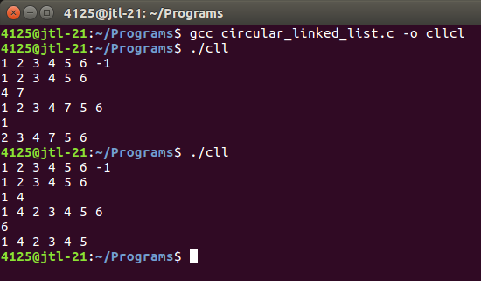

#include<stdio.h>
#include<stdlib.h>
struct node
{
int data;
struct node *next,*back;
};
typedef struct node Node;
Node * getnode()
{
return (Node *)malloc(sizeof(Node));
}
void display(Node * head, Node * tail)
{
Node *t;
for(t=head;t!=NULL;t=t->next)
printf("%d ",t->data);
printf("\n");
for(t=tail;t!=NULL;t=t->back)
printf("%d ",t->data);
printf("\n");
}
Node * ins_head(Node * head, int val)
{
Node *p;
p=getnode();
p->back=NULL;
p->data=val;
p->next=head;
head->back=p;
head=p;
return head;
}
Node * ins_tail(Node * tail, int val)
{
Node *p;
p=getnode();
p->data=val;
p->back=tail;
p->next=NULL;
tail->next=p;
tail=p;
return tail;
}
Node * insert(Node * head, int ref, int val)
{
Node *t,*p;
for(t=head;t->data!=ref && t->next!=NULL;t=t->next);
p=getnode();
p->data=val;
p->next=t->next;
p->back=t;
t->next->back=p;
t->next=p;
return head;
}
Node * del_head(Node * head)
{
Node *p;
p=head;
head=head->next;
free(p);

head->back=NULL;
return head;
}
Node * del_tail(Node * tail)
{
Node *p;
p=tail;
tail=tail->back;
free(p);
tail->next=NULL;
return tail;
}
Node * delete(Node * head, int ref)
{
Node *t,*p;
for(t=head;t->data!=ref && t->next!=NULL;t=t->next);
p=t;
t->next->back=t->back;
t->back->next=t->next;
free(p);
return head;
}
void main()
{
Node *head,*tail,*prev,*temp;
int n,ri,val,rd;
head=NULL;
scanf("%d",&n);
while(n!=-1)
{
if(head==NULL)
{
head=getnode();
head->back=NULL;
head->data=n;
head->next=NULL;
prev=head;
}
else
{
temp=getnode();
temp->data=n;
temp->next=NULL;
prev->next=temp;
temp->back=prev;
prev=temp;
}
scanf("%d",&n);
}
tail=prev;
display(head,tail);
scanf("%d %d",&ri,&val);
if(head->data==ri)
head=ins_head(head,val);
else if(tail->data==ri)
tail=ins_tail(tail,val);
else
head=insert(head,ri,val);
display(head,tail);
scanf("%d",&rd);
if(head->data==rd)
head=del_head(head);
else if(tail->data==rd)

tail=del_tail(tail);
else
head=delete(head,rd);
display(head,tail);
}

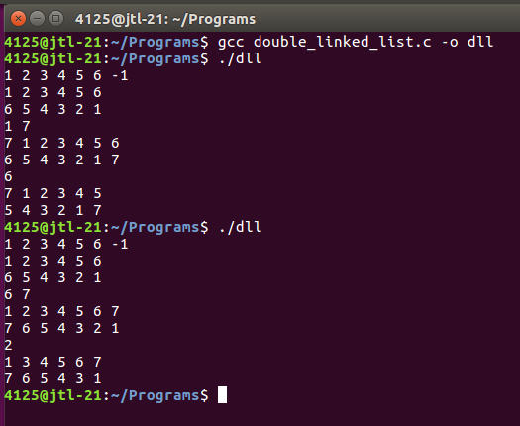

#include<stdio.h>
#include<stdlib.h>
struct node
{
int data;
struct node *next,*back;
};
typedef struct node Node;
Node * getnode()
{
return (Node *)malloc(sizeof(Node));
}
void display(Node * head, Node * tail)
{
Node *t=head;
do
{
printf("%d ",t->data);
t=t->next;
}while(t!=head);
printf("\n");
t=tail;
do
{
printf("%d ",t->data);
t=t->back;
}while(t!=tail);
printf("\n");
}
Node * ins_head(Node * head, int val)
{
Node *p;
p=getnode();
p->back=NULL;
p->data=val;
p->next=head;
head->back=p;
head=p;
return head;
}
Node * ins_tail(Node * tail, int val)
{
Node *p;
p=getnode();
p->data=val;
p->back=tail;
p->next=NULL;
tail->next=p;
tail=p;
return tail;
}
Node * insert(Node * head, int ref, int val)
{
Node *t,*p;
for(t=head;t->data!=ref && t->next!=head;t=t->next);
p=getnode();
p->data=val;
p->next=t->next;
p->back=t;
t->next->back=p;
t->next=p;
return head;
}

Node * del_head(Node * head)
{
Node *p;
p=head;
head=head->next;
free(p);
head->back=NULL;
return head;
}
Node * del_tail(Node * tail)
{
Node *p;
p=tail;
tail=tail->back;
free(p);
tail->next=NULL;
return tail;
}
Node * delete(Node * head, int ref)
{
Node *t,*p;
for(t=head;t->data!=ref && t->next!=head;t=t->next);
p=t;
t->next->back=t->back;
t->back->next=t->next;
free(p);
return head;
}
void main()
{
Node *head,*tail,*prev,*temp;
int n,ri,val,rd;
head=NULL;
scanf("%d",&n);
while(n!=-1)
{
if(head==NULL)
{
head=getnode();
head->back=NULL;
head->data=n;
head->next=NULL;
prev=head;
}
else
{
temp=getnode();
temp->data=n;
temp->next=NULL;
prev->next=temp;
temp->back=prev;
prev=temp;
}
scanf("%d",&n);
}
tail=prev;
tail->next=head;
head->back=tail;
display(head,tail);
scanf("%d %d",&ri,&val);
if(head->data==ri)
{

head=ins_head(head,val);
head->back=tail;
tail->next=head;
}
else if(tail->data==ri)
{
tail=ins_tail(tail,val);
tail->next=head;
head->back=tail;
}
else
head=insert(head,ri,val);
display(head,tail);
scanf("%d",&rd);
if(head->data==rd)
{
head=del_head(head);
head->back=tail;
tail->next=head;
}
else if(tail->data==rd)
{
tail=del_tail(tail);
tail->next=head;
head->back=tail;
}
else
head=delete(head,rd);
display(head,tail);
}

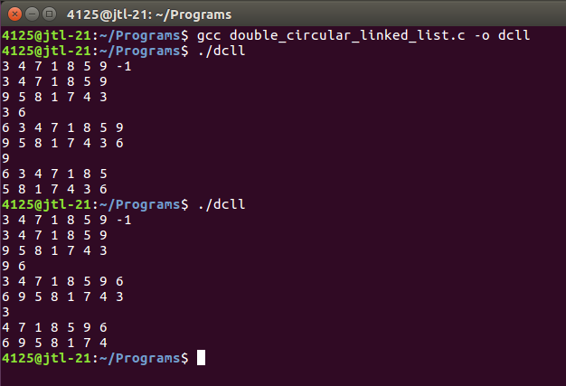

#include<stdio.h>
#include<stdlib.h>
struct node
{
int coeff,pow;
struct node *next;
};
typedef struct node Node;
Node * getnode()
{
return (Node *)malloc(sizeof(Node));
}
Node * assign(Node * a, int n)
{
Node *q,*t;
int b;
q=getnode();
for(int i=n;i>=0;i--)
{
scanf("%d",&b);
if(a==NULL)
{
a=getnode();
a->coeff=b;
a->pow=i;
a->next=NULL;
q=a;

}
else
{
t=getnode();
t->coeff=b;
t->pow=i;
t->next=NULL;
q->next=t;
q=t;
}
}
return a;
}
Node * sum1(Node * a, Node * b, Node * sum)
{
Node *q,*t;
q=getnode();
for(;a!=NULL && b!=NULL;a=a->next,b=b->next)
{
if(sum==NULL)
{
sum=getnode();
sum->coeff=a->coeff+b->coeff;
sum->pow=a->pow;
sum->next=NULL;
q=sum;
}
else
{
t=getnode();
t->coeff=a->coeff+b->coeff;
t->pow=a->pow;
t->next=NULL;
q->next=t;

q=t;
}
}
return sum;
}
void display(Node *a)
{
Node *t;
for(t=a;t!=NULL;t=t->next)
printf("%dx^%d%c",t->coeff,t->pow,t->next==NULL?' ':'+');
printf("\n");
}
int main()
{
Node *eq1,*eq2,*sum;
int n;
eq1=NULL;
eq2=NULL;
sum=NULL;
scanf("%d",&n);
eq1=assign(eq1,n);
eq2=assign(eq2,n);
sum=sum1(eq1,eq2,sum);
display(eq1);
display(eq2);
display(sum);
}

